**UTS PBW MEMBUAT DESAIN WEB PENJUALAN TANAMAN HIAS**

NAMA : KHAIRUL UMAR AKHSAN

NIM : A11.2020.12888

KELOMPOK : A11.4307

1. **Desain Home:**

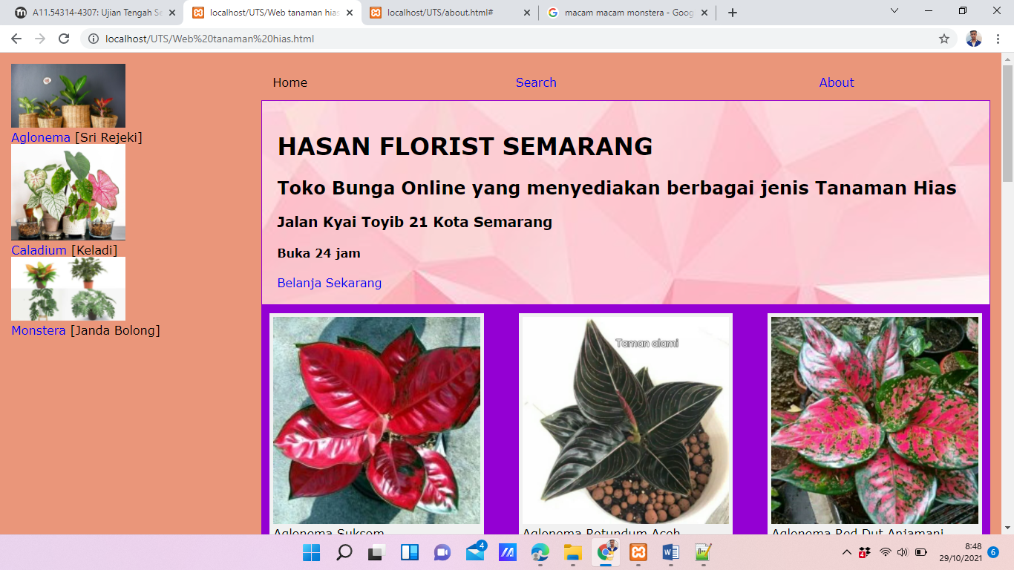

1. **Desain Belanja:**

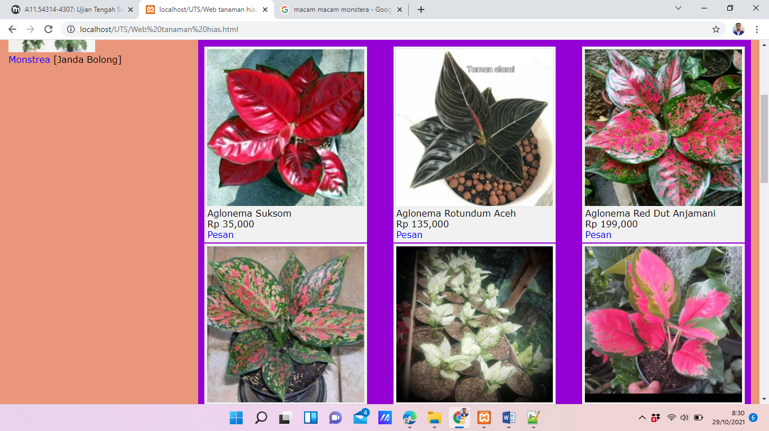

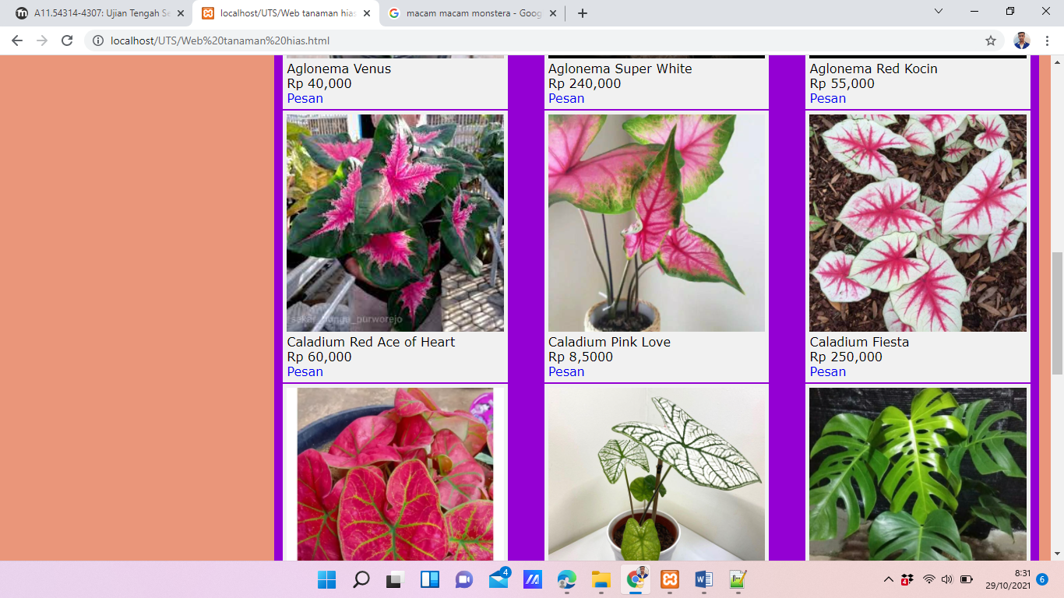

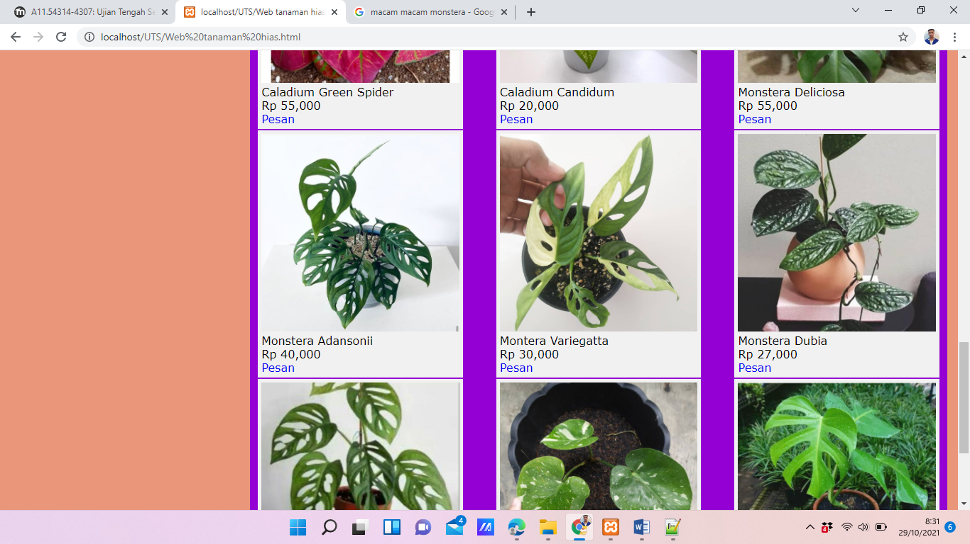

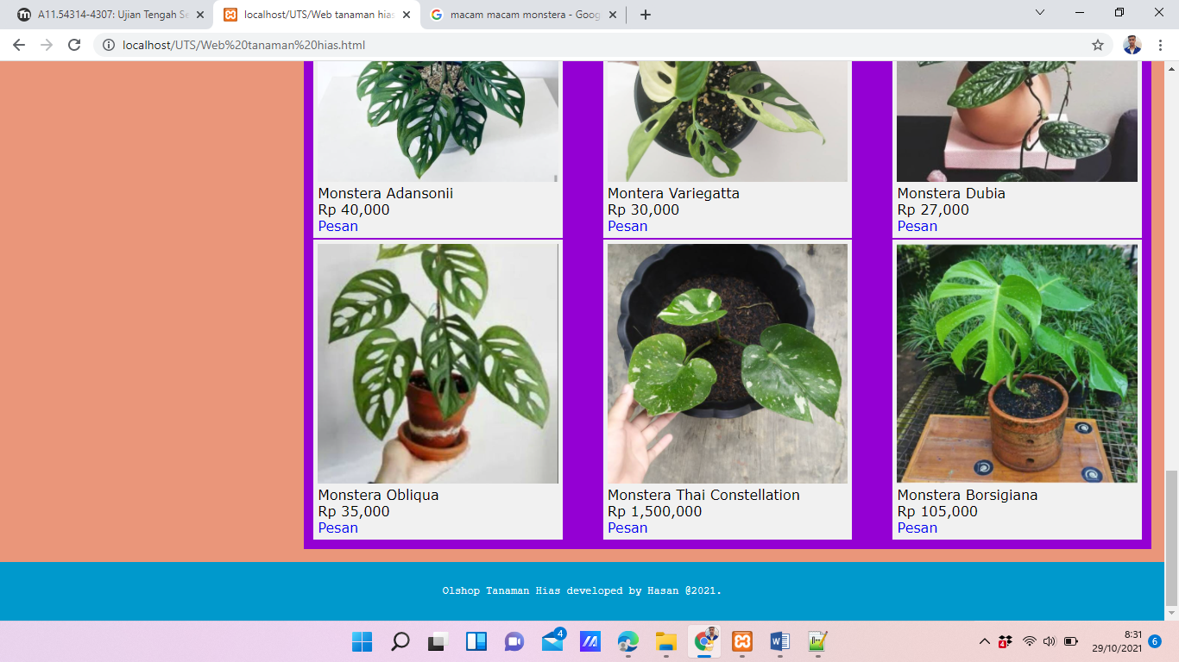

1. **Desain About:**

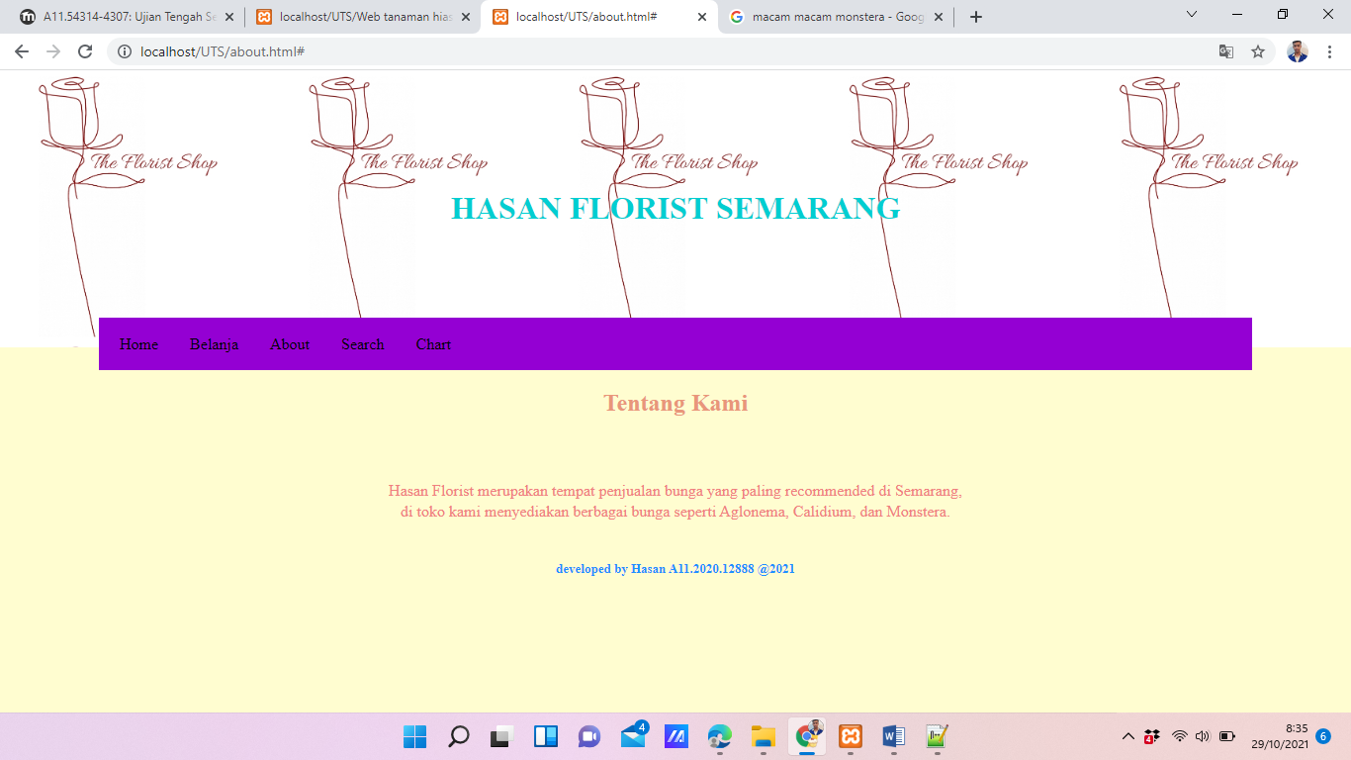

1. **CODE Web Penjualan Tanaman:**

<!DOCTYPE html>

<html>

<head>

<meta name="viewport" content="width=device-width, initial-scale=1.0">

<style>

body {

background-image:url("img/darksalmon.png");

background-size:100% 100%;

background-attachment:fixed;

background-repeat:no-repeat;

}

* {

box-sizing: border-box;

}

body { margin:0;}

img {

width: 100%;

height: auto;

}

.row:after {

content: "";

clear: both;

display: table;

}

[class*="col-"] {

float: left;

padding: 15px;

}

.col-1 {width: 8.33%;}

.col-2 {width: 16.66%;}

.col-3 {width: 25%;}

.col-4 {width: 33.33%;}

.col-5 {width: 41.66%;}

.col-6 {width: 50%;}

.col-7 {width: 58.33%;}

.col-8 {width: 66.66%;}

.col-9 {width: 75%;}

.col-10 {width: 83.33%;}

.col-11 {width: 91.66%;}

.col-12 {width: 100%;}

}

<style type="text/css">

body { font-family: Arial; }

p { font-family: Courier, monospace; }

div { font-family: “Duru Sans”, Verdana, sans-serif; }

}

.header {

background-color: #9933cc;

color: #ffffff;

padding: 15px;

}

.footer {

background-color: #0099cc;

color: #ffffff;

text-align: center;

font-size: 12px;

padding: 15px;

}

.head1 {display:flex;

background-color:DarkViolet;

flex-wrap:wrap;

justify-content:space-between;

align-content:space-between;

}

.head1 > div {

flex-wrap:wrap;

margin:1px;

padding:5px;

background-color:#f1f1f1;

}

a {text-decoration:none;}

</style>

</head>

<body>

<div class="row">

<div class="col-3">

<img src="img/aglonema_kategori.jpg" style="width:50%;height:auto;">

<br>

<div><a href="#">Aglonema</a> <span>[Sri Rejeki]</span></div>

<img src="img/logo_caladium.jpg" style="width:50%;height:auto;">

<br>

<div><a href="#">Caladium</a> <span> [Keladi]</span></div>

<img src="img/logo_monstera.jpg" style="width:50%;height:auto;">

<br>

<div><a href="#">Monstrea</a> <span> [Janda Bolong]</span></div>

</div>

<div class="col-9">

<div class="row">

<div class="col-4">Home</div>

<div class="col-5"><a href="#">Search</a></div>

<div class="col-3"><a href="#">About</a></div>

</div>

<div class="head1" >

<div style="width:100%;

background-image:url('img/pink.jpg');

background-repeat:no-repeat;

background-size:100% auto; padding:20px;">

<h1>HASAN FLORIST SEMARANG</h1>

<h2>Toko Bunga Online yang menyediakan berbagai jenis Tanaman Hias</h2>

<h3>Jalan Kyai Toyib 21 Kota Semarang</h3>

<h4>Buka 24 jam</h4>

<a href="#">Belanja Sekarang</a>

</div>

</div>

<div class="head1" style="padding:10px;" >

<div style="width:30%">

<img src="img/aglonemaSuksom.jpg"><br>

Aglonema Suksom<br>

Rp 35,000<br>

<a href="#">Pesan</a>

</div>

<div style="width:30%">

<img src="img/aglonemaRotundumAceh.jpg"><br>

Aglonema Rotundum Aceh <br>

Rp 135,000<br>

<a href="#">Pesan</a>

</div>

<div style="width:30%">

<img src="img/aglonema 1.jpg"><br>

Aglonema Red Dut Anjamani <br>

Rp 199,000<br>

<a href="#">Pesan</a>

</div>

<div style="width:30%">

<img src="img/aglonema 2.jpg"><br>

Aglonema Venus<br>

Rp 40,000<br>

<a href="#">Pesan</a>

</div>

<div style="width:30%">

<img src="img/aglonemaSuperWhite.jpg"><br>

Aglonema Super White<br>

Rp 240,000<br>

<a href="#">Pesan</a>

</div>

<div style="width:30%">

<img src="img/aglonemaRedChocin.jpg"><br>

Aglonema Red Kocin<br>

Rp 55,000<br>

<a href="#">Pesan</a>

</div>

<div style="width:30%">

<img src="img/caladium_ace_of_heart.jpg"><br>

Caladium Red Ace of Heart<br>

Rp 60,000<br>

<a href="#">Pesan</a>

</div>

<div style="width:30%">

<img src="img/Caladium_pink_love.jpg"><br>

Caladium Pink Love<br>

Rp 8,5000 <br>

<a href="#">Pesan</a>

</div>

<div style="width:30%">

<img src="img/caladium 1.jpg"><br>

Caladium Fiesta<br>

Rp 250,000 <br>

<a href="#">Pesan</a>

</div>

<div style="width:30%">

<img src="img/caladium 3.webp"><br>

Caladium Green Spider<br>

Rp 55,000 <br>

<a href="#">Pesan</a>

</div>

<div style="width:30%">

<img src="img/caladium_candidum.jpg"><br>

Caladium Candidum<br>

Rp 20,000 <br>

<a href="#">Pesan</a>

</div>

<div style="width:30%">

<img src="img/monstera 1.jpg"><br>

Monstera Deliciosa<br>

Rp 55,000 <br>

<a href="#">Pesan</a>

</div>

<div style="width:30%">

<img src="img/monstera 4.jpg"><br>

Monstera Adansonii<br>

Rp 40,000 <br>

<a href="#">Pesan</a>

</div>

<div style="width:30%">

<img src="img/monstera 5.jpg"><br>

Montera Variegatta<br>

Rp 30,000 <br>

<a href="#">Pesan</a>

</div>

<div style="width:30%">

<img src="img/monstera 2.jpg"><br>

Monstera Dubia<br>

Rp 27,000 <br>

<a href="#">Pesan</a>

</div>

<div style="width:30%">

<img src="img/monstera 6.jpg"><br>

Monstera Obliqua<br>

Rp 35,000 <br>

<a href="#">Pesan</a>

</div>

<div style="width:30%">

<img src="img/monstera 7.jpg"><br>

Monstera Thai Constellation<br>

Rp 1,500,000 <br>

<a href="#">Pesan</a>

</div>

<div style="width:30%">

<img src="img/monstera 8.jpg"><br>

Monstera Borsigiana<br>

Rp 105,000 <br>

<a href="#">Pesan</a>

</div>

</div>

</div>

</div>

<div class="footer">

<p>Olshop Tanaman Hias developed by Hasan @2021.</p>

</div>

</body>

</html>

1. **CODE About**:

<html>

<head>

<style>

*{ box-sizing :border box;

}

body{

background-color:#FFFDD0;

background-size:100%

}

h1{

font-family:humanist;

color : darkturquoise;

text-align:center;

}

h4{

font-family:Times New Roman;

text-align:center;

color:green;

}

body {

margin: 0;}

.header {

padding: 100px;

text-align: center;

color : darkturquoise;

background:url("img/logo4.jpg");

background-size:20%;

}

.topnav {

background-color:darkviolet;

margin: 100px;

padding: 5px;

overflow: auto;

line-height:15px;

margin-top:-30px;

}

.topnav a {

float: left;

display: block;

color:blue

text-align: center;

padding: 14px 16px;

text-decoration: none;

}

.topnav a:hover {

background-color:#1114FB;

color: white;

}

p{

color: lightcoral;

line-height:5px;

font-size:16px;

}

h2{

color :darksalmon;

margin-top:-80px;

}

h5{

margin-top:-10px;

}

h4{

color :dodgerblue ;

}

div.name{

padding: 15px;

text-align: center;

}

div.name a{

color:blue;

font-weight: bold;

}

div.name a:hover{

color:orange;

}

div.desc{

padding:10px;

text-align:justify;

color:black;

}

div.price{

padding:15px;

text-align:right;

text-color:white;

}

/* unvisited link */

a:link {

color: black;

}

/* visited link */

a:visited {

color: black;

}

/* mouse over link */

a:hover {

color: hotpink;

}

.buttonbuy {

background-color:rgb(0, 132, 255);

border-radius:10px;

color:white;

margin:15px;

text-align: center;

padding: 5px;

}

.button {

background-image:green;

border-radius:15px;

color:white;

margin:1px;

text-align: center;

padding:1px;

}

* {

box-sizing: border-box;

}

input[type=text], select, textarea {

width: 100%;

padding: 12px;

border: 1px solid #ccc;

border-radius: 4px;

resize: vertical;

}

label {

padding: 12px 12px 12px 0;

display: inline-block;

}

input[type=submit] {

background-color: #4CAF50;

color: white;

padding: 12px 20px;

border: none;

border-radius: 4px;

cursor: pointer;

float: right;

}

input[type=submit]:hover {

background-color: #45a049;

}

.container {

border-radius: 5px;

background-color: #f2f2f2;

padding: 20px;

}

.report{

height:50px;

float:left;

width:100%;

margin:10px;

color:green;

padding:6px;

text-align:center;

}

.col-25 {

float: left;

width: 25%;

margin-top: 6px;

}

.col-75 {

float: left;

width: 75%;

margin-top: 6px;

}

/* Clear floats after the columns */

.row:after {

content: "";

display: table;

clear: both;

}

/* Responsive layout - when the screen is less than 600px wide, make the

two columns stack on top of each other instead of next to each other */

@media screen and (max-width: 600px) {

.col-25, .col-75, input[type=submit] {

width: 100%;

margin-top: 0;

}

}

.footer {

color:black;

text-align: center;

font-size: 13px;

padding: 15px;

}

</style>

</head>

<body>

<div class="header">

<h1>HASAN FLORIST SEMARANG</h1>

</div>

<div class="topnav">

<a href="HomeUTS.html" >Home</a>

<a href="BelanjaUTS.html" title="Gass belanja gess">Belanja</a>

<a href="AboutUTS.html" title="Tentang Kita nih">About</a>

<a href="#" title="Silahkan Cari">Search</a>

<a href="#" title="Silahkan Cari">Chart</a>

</div>

<div class="row">

<div class="coloumn">

<h2 align="center">Tentang Kami</h2><br></br>

<p align="center">Hasan Florist merupakan tempat penjualan

bunga yang paling recommended di Semarang,</p>

<p align="center">di toko kami menyediakan berbagai bunga seperti

Aglonema, Calidium, dan Monstera.</p>

</div>

</div>

<div class="footer">

<h4>developed by Hasan A11.2020.12888 @2021 </h4>

</div>

</body>